----------------------------------------------------------------------------------------------------------------
NAME: VISHAL.V
REG.NO: 192419033
COURSE CODE: ECA0404
COURSE NAME: ANALOG CIRCUITS
PRACTICAL LAB RESULTS
----------------------------------------------------------------------------------------------------------------
EXP-5 (LT spice experiment)
CIRCIUT DIAGRAM:
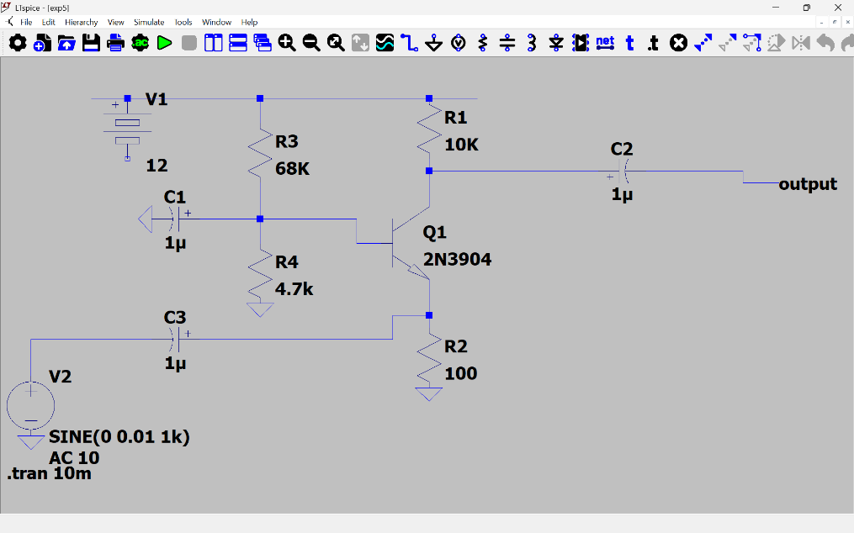

PROCEDURE:
1. Voltage Gain Analysis: -
- Open LTSpice and create a new schematic.
- Place the NPN transistor and biasing resistors.
- Configure the Common Base amplifier circuit.
- Apply the AC input signal.
- Set the simulation parameters.
- Run the simulation.
- Measure the input and output voltages.
- Calculate the voltage gain using:
- Record the observations.
2. Input and Output Characteristics: -
- Configure DC sweep analysis.
- Vary the emitter voltage and measure emitter current.
- Plot the input characteristics.
- Vary the collector voltage and measure collector current.
- Plot the output characteristics.
- Determine the required characteristics/resistances.
3. Frequency Response Analysis: -
- Configure AC analysis in LTSpice.
- Sweep the frequency from 10 Hz to 100 MHz.
- Observe the amplifier gain.
- Plot the Bode response.
- Determine the lower and upper cutoff frequencies.
- Calculate the bandwidth.
- Record the observations.

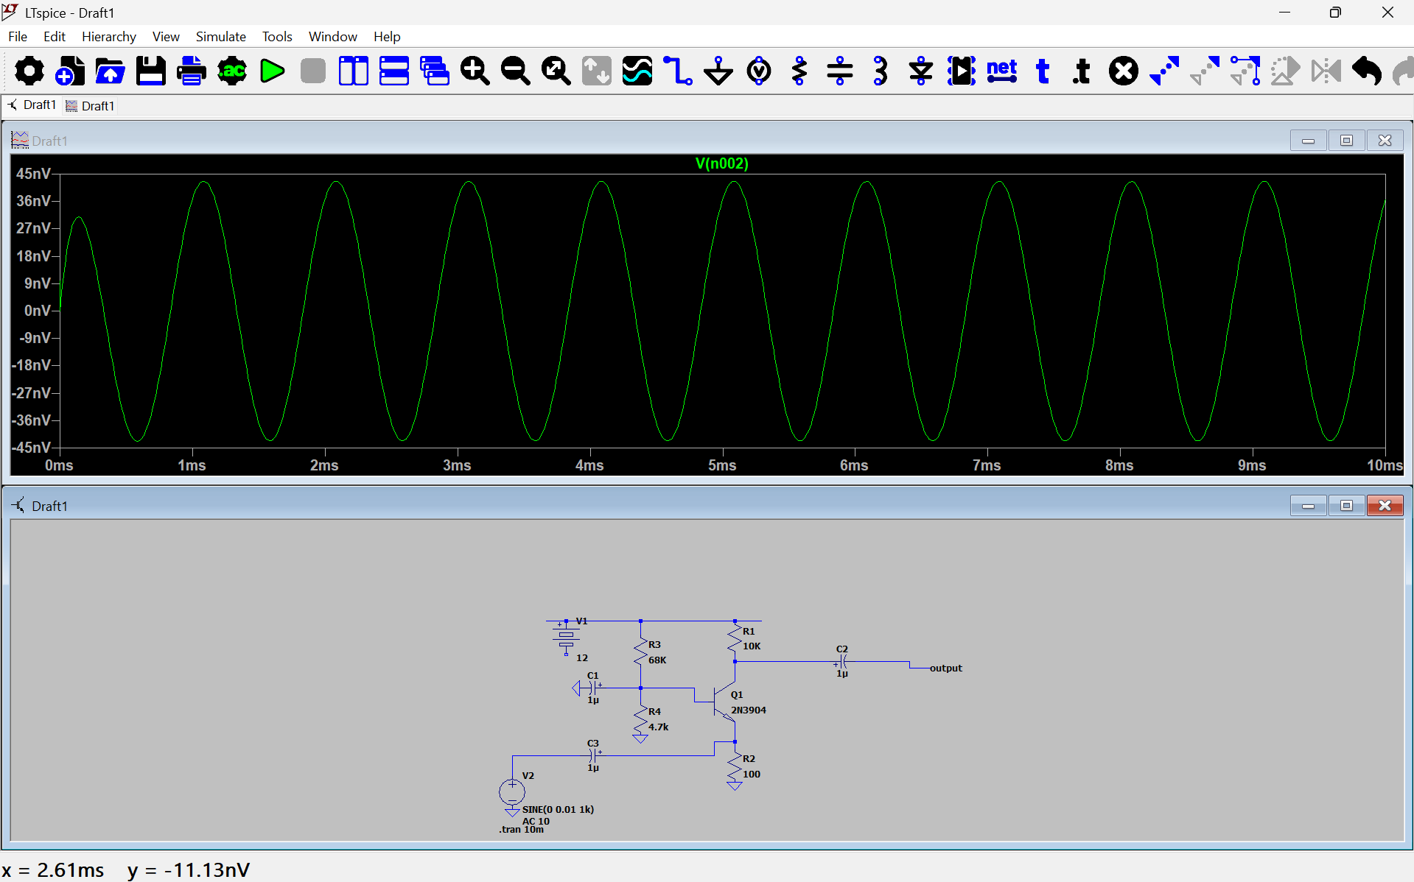
OUTPUT(GRAPH): -

